Pac-Poly-Tahiti-Hula-An Exact Representation of a Dance-Webber-Cook-1786

## An Exact Representation of a Dance in Otaheite

33 cm x 20 cm copperplate engraving, 35 cm x 23 cm sheet size, modern hand colour, Alexander Hogg, London, 1784-1786

We are pleased to offer this scarce and historically important original fine art engraving after an original drawing by the [*HMS Resolution*](http://en.wikipedia.org/wiki/HMS_Resolution_(1771))ship's artist [John Webber](http://en.wikipedia.org/wiki/John_Webber) (1751-1793) on James Cook's third and final voyage from the *New, Authentic, Entertaining, Instructive, Full and Complete Historical Account of Captain Cook's First, Second, Third and Last Voyages*[1](http://vi.vipr.ebaydesc.com/ws/eBayISAPI.dll?ViewItemDescV4&item=261693525589&t=1395522164000&tid=10&category=360&seller=regiomontanus&excSoj=1&excTrk=1&lsite=0&ittenable=false&domain=ebay.com&descgauge=1" \l "1) published serially between 1784 and 1786.  The historically important drawing was sketched in September 1777 and depicts a ceremonial dance witnessed by Cook and Webber in Tahiti.  Cook described the performance in his journal:

"…a kind of private Heeva (Heiva) or amusement, which consisted of about a hundred of the inhabitants of the neighbourhood who were sitting in a house and in the midst of them two women with an old man behind, each beating very gently upon a drum, and the women at intervals singing in a softer manner than I ever heard at their other diversions. The assembly listened with great attention and were seemingly almost absorbed in the pleasure the music gave them, as few took any notice of us and the performers never once stop’d"2

Webber was recommended to the Admiralty for appointment as artist for the voyage by the Swedish botanist [Daniel Carlsson Solander](http://en.wikipedia.org/wiki/Daniel_Solander) (1733-1782) who had accompanied Cook on his first voyage.  Just 24 years old when he joined the *Resolution* at Plymouth one week prior to departure,  Webber's skill in both portraiture and landscape resulted in a visual record of Cook's third voyage that is unsurpassed in the annals of 18th century exploration.  In their monumental four-volume work *The Art of Captain Cook's Voyages*3 authors Rüdiger Joppien and Bernard Smith observe that Webber's relationship with Cook was unique, noting that:

"Cook clearly had it in mind on this voyage to publish his own account on his return and it is also clear that he regarded Webber as his visual collaborator in that undertaking from the beginning... Webber is frequently on the spot with Cook and often depicts incidents, scenes or portraits of individuals mentioned by Cook in his journal... In Webber's drawings with their emphasis upon description, the recording of notable events, and linear accuracy, we may perhaps see something of Cook's guiding hand..."

An iconic image that is a true classic of Pacific illustration, this handsomely engraved strong imprint is enhanced by finely executed hand colour work.  One of the most sought-after of 18th century prints of Webber's illustrations, this handsome example will make an elegant presentation if matted and framed and an important addition to any collection related to Tahiti and Polynesian culture or the voyages of James Cook.

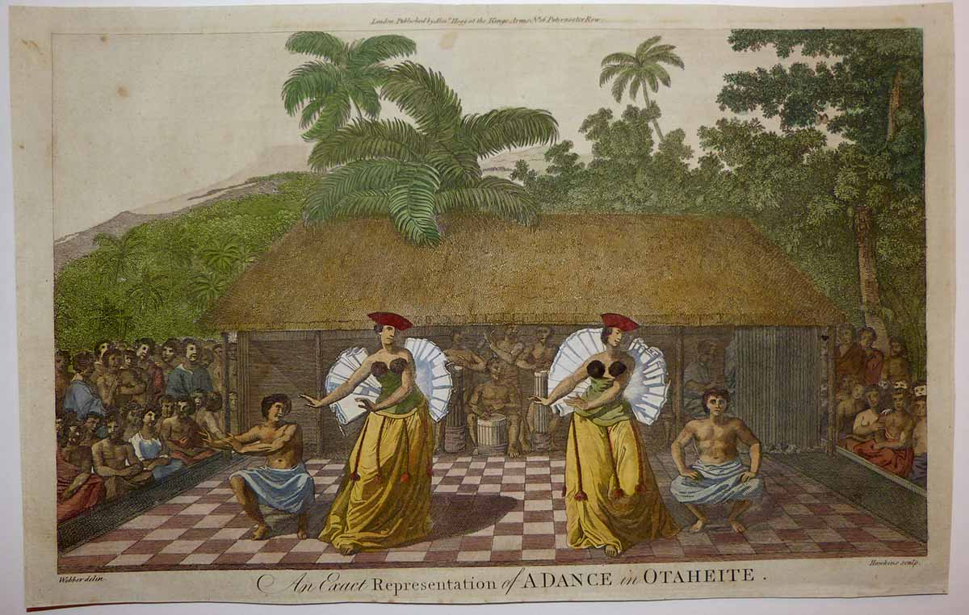

To get a sense of print detail consider that the female dancers stand just 9 cm tall actual size:

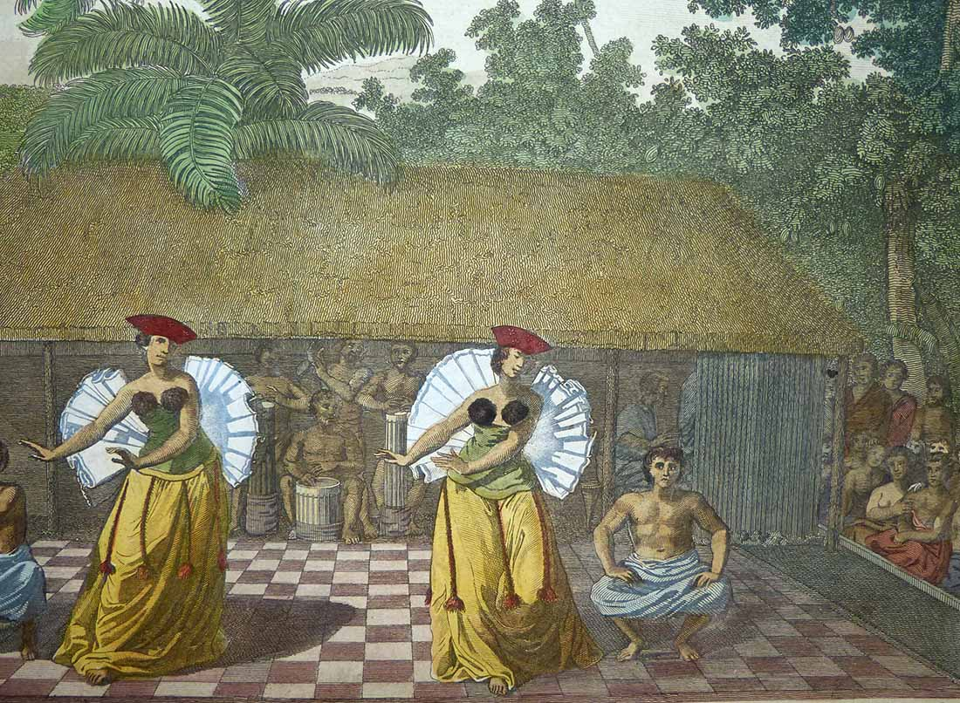

In Tahiti, the word Heiva (hei meaning to assemble, and va meaning community places) was long associated with music and dance, and could be important religious and political ceremonies or merely celebratory performances. Cook clearly recognised the sophistication of the ritual art forms he witnessed at these "diversions" and would undoubtedly be glad to see that the Heiva has undergone a resurgence in recent years after decades of suppression by Christian missionaries and an outright ban by the Christian convert [King Pomare II](http://en.wikipedia.org/wiki/Pōmare_II) in 1819.

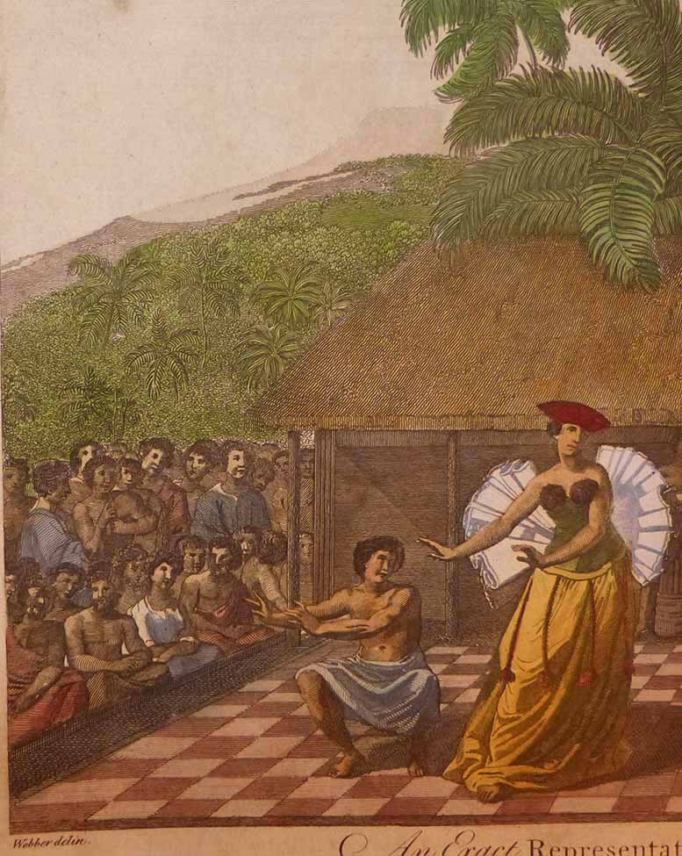

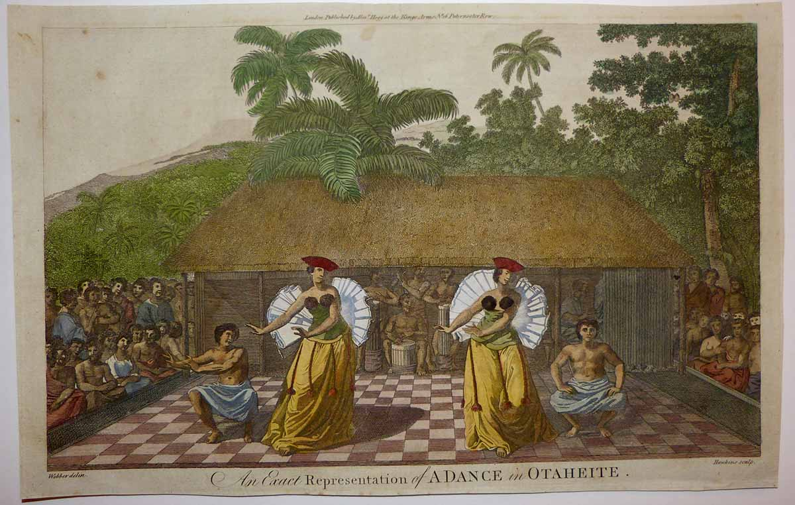

Condition - Please note carefully:  The print is in very good condition as can be ascertained from photos, a few tiny faint spots in unprinted sky but otherwise image area essentially pristine, no text on verso, no folds, strong impresssion on fine quality laid paper, well-executed hand colour work, close and somewhat uneven trim to all margins.  A remnant of old paper reinforcement is present on verso extending ~ 35 mm from margin edge that appears to have reinforced a weakened line of the laid paper directly along one of the vertical chain lines which shows a trivial creasing in unprinted sky.  Image of print shows it lying flat in free state with all edges shown for evaluation.   [Inquiries](mailto:jfazli@ix.netcom.com) welcome and we encourage you to visit our other [listings](http://cgi6.ebay.com/aw-cgi/eBayISAPI.dll?ViewListedItems&userid=regiomontanus&sort=3&since=-1) on eBay.  
  
NOTES:  
  
1. The editor of the *New, Authentic, Entertaining, Instructive, Full and Complete Historical Account of Captain Cook's First, Second, Third and Last Voyages* was named as one "George William Anderson",  almost certainly a pseudonym for the publisher Alexander Hogg.  In a recent exhibition of these historically important engravings made for this publication the Lowe Art Museum in Miami noted that the pseudonym was "a device Hogg employed in a number of his publications" intended to convey an "aura of authoritative knowledge" regarding his editing of the official publications of the voyages.  Hogg shrewdly elected to publish the work (which eventually included accounts of other circumnavigations) in a relatively affordable serial format from 1784-1786 to reach a broad audience, noting in his marketing copy that this was "due to the many thousands of Persons who would wish to peruse the Discoveries... and view the astonishing fine Copper-Plates, who have hitherto been excluded from gratifying their eager curiosity.  These installments would allow every Person, whatever may be his Circumstances, to read about the voyages of which such vast Sums of the Public Money have been expended."  
  
2.  Cook, James. *A Voyage Towards the South Pole and Round the World: Performed in His Majesty’s Ships the Resolution and Adventure, in the Years 1772, 1773, 1774 and 1775*. 1st ed. 2 vols. London, 1777  
   
3.  New Haven; Four Volumes, Published for the Paul Mellon Centre for Studies in British Art by Yale University Press 1985-1988